Q7. Use appropriate smoothing and sharpening techniques to enhance the clarity of the images provided in the Module Section under Experiment 9. CO3, CO4
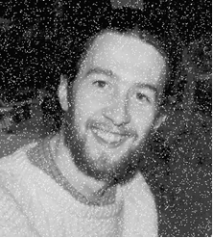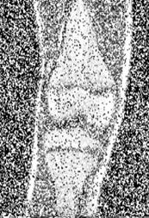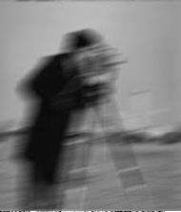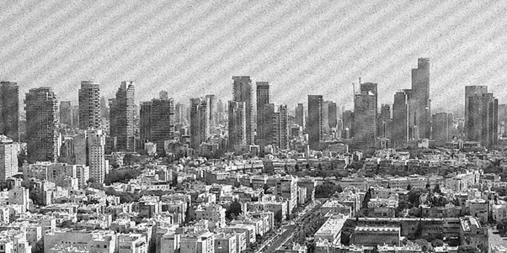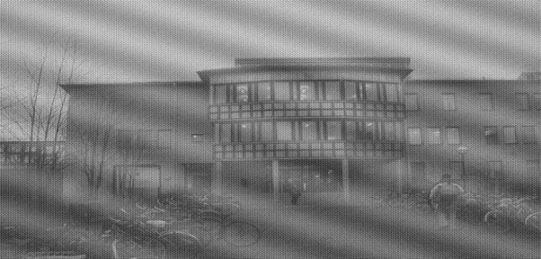
Apply multiple filters, observe the changes produced by each method, and document your observations in detail.Discuss how smoothing and sharpening individually affect image quality, and summarize your conclusions based on the results.

Code:

!pip install -q opencv-python matplotlib numpy

import cv2
import numpy as np
import matplotlib.pyplot as plt

image_paths = [
"/content/Picture1.png",
"/content/Picture2.png",
"/content/Picture3.png",
"/content/Picture4.png",
"/content/Picture5.png"
]

images = []

for p in image_paths:
img = cv2.imread(p, 0)
if img is not None:
images.append(img)
print("Loaded:", p)
else:
print(" Missing:", p)

smooth_results = []
sharp_results = []

for img in images:

avg = cv2.blur(img, (5,5))
gauss = cv2.GaussianBlur(img, (5,5), 1)
median = cv2.medianBlur(img, 5)
bilateral = cv2.bilateralFilter(img, 9, 75, 75)

smooth_results.append([img, avg, gauss, median, bilateral])

lap = cv2.Laplacian(img, cv2.CV_64F)
lap = cv2.convertScaleAbs(lap)
lap_sharp = cv2.addWeighted(img, 1.0, lap, 1.0, 0)

blur = cv2.GaussianBlur(img, (9,9), 2)

unsharp = cv2.addWeighted(img, 1.5, blur, -0.5, 0)

k = 1.8
highboost = cv2.addWeighted(img, k, blur, -(k-1), 0)

sharp_results.append([img, lap_sharp, unsharp, highboost])

titles_smooth = ["Original", "Averaging", "Gaussian", "Median", "Bilateral"]

plt.figure(figsize=(14, 12))
plt.suptitle("Smoothing Results for All Images", fontsize=18)

rows = len(images)
cols = 5

for r in range(rows):
for c in range(cols):
plt.subplot(rows, cols, r*cols + c + 1)
plt.imshow(smooth_results[r][c], cmap='gray')
if r == 0:
plt.title(titles_smooth[c], fontsize=12)
plt.axis("off")

plt.tight_layout()
plt.show()

titles_sharp = ["Original", "Laplacian", "Unsharp Mask", "High-Boost"]

plt.figure(figsize=(14, 10))
plt.suptitle("Sharpening Results for All Images", fontsize=18)

rows = len(images)
cols = 4

for r in range(rows):
for c in range(cols):
plt.subplot(rows, cols, r*cols + c + 1)
plt.imshow(sharp_results[r][c], cmap='gray')
if r == 0:
plt.title(titles_sharp[c], fontsize=12)
plt.axis("off")

plt.tight_layout()
plt.show()

OUTPUT:
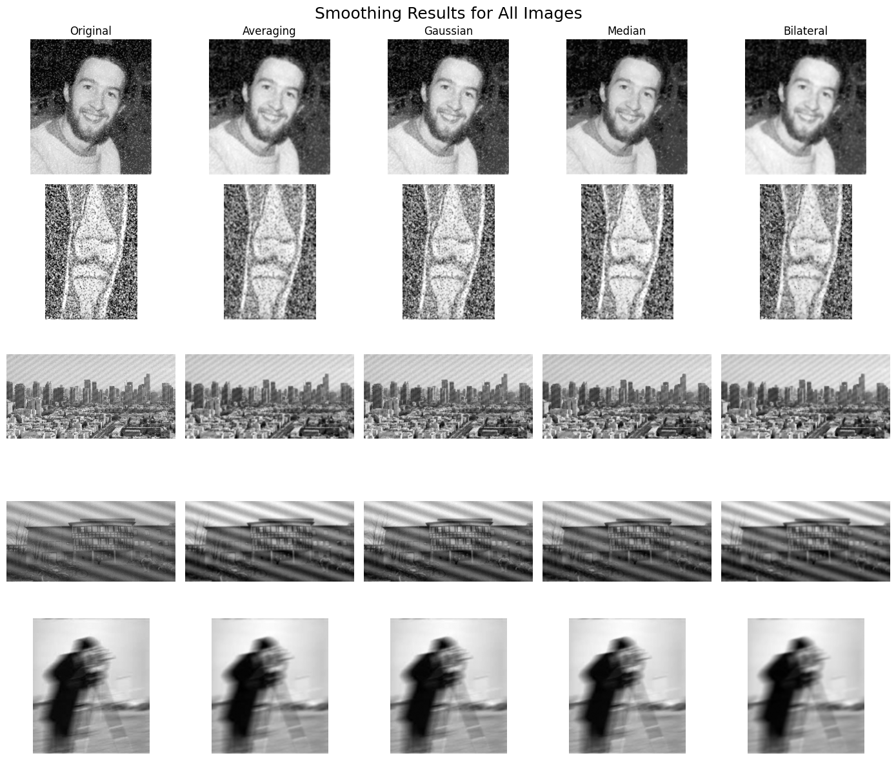

Obsevation:

Smoothing Techniques
- Averaging Filter: Reduced noise but caused noticeable blurring and loss of detail.
- Gaussian Filter: Smoothed images more naturally and preserved edges better than averaging.
- Median Filter: Very effective for salt-and-pepper noise; preserved edges well.
- Bilateral Filter: Best smoothing output; removed noise while keeping edges sharp and clear.

Sharpening Techniques
- Laplacian Sharpening: Enhanced edges strongly but amplified noise in degraded images.
- Unsharp Masking: Produced clean and natural sharpening with good detail recovery.
- High-Boost Filter: Provided strongest sharpening but increased noise if boosted too much.
Conclusion:
Smoothing and sharpening techniques each improve image quality in different ways. Smoothing filters reduce noise and make images cleaner, with the bilateral and median filters performing best by preserving important edges. Sharpening filters enhance details and improve clarity, with unsharp masking giving the most natural results. Overall, a combination of smoothing (to remove noise) followed by sharpening (to restore fine details) provides the best enhancement for degraded images.

